Chapter 11, Solution 14.

Using Fig. 11.45, design a problem to help other students better understand maximum average power transfer.

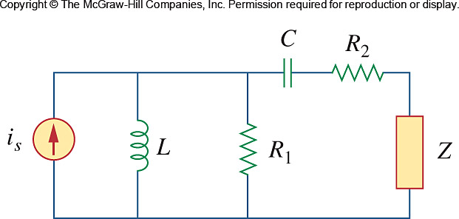

Figure 11.45
For Prob. 11.14.

Solution

Although there are many ways to work this problem, this is an example based on the same kind of problem asked in the third edition.

Problem

It is desired to transfer maximum power to the load Z in the circuit of Fig. 11.45. Find Z and the maximum power. Let A.

40 mF 8 Ω

i_{s} 7.5 mH 12 Ω Z

Figure 11.45 For Prob. 11.14.

Solution

We find the Thevenin equivalent at the terminals of Z.

40 mF
7.5 mH

To find Z_{Th}, consider the circuit below.
-j0.625 8 Ω

j0.3 12 Ω Z_{Th}

Z_{L} = (Z_{Thev})* = [8.008 + j0.3252] Ω.

To find V_{Th}, consider the circuit below.

-j0.625 8 Ω

I₁ +

5∠0º j0.3 12 Ω V_{Th}

–

By current division,

I₁ = 5(j0.3)/(12+j0.3) = 1.5∠90˚/12.004∠1.43˚ = 0.12496∠88.57˚

= 0.003118 + j0.12492A

V_{Thev rms} = 12I₁/ = 1.0603∠88.57˚V

I_{Lrms} = 1.0603∠88.57˚/2(8.008) = 66.2∠88.57˚mA

P_{avg} = |I_{Lrms}|²8.008 = 35.09 mW.

